Run EmpowerSupport
You can run EmpowerSupport from Start Menu All Programs EmpowerNET EmpowerSupport. EmpowerSupport must be run with administrator privileges. If you are running with User Account Control turned on, you will be prompted to allow the application to run as an administrator; click Yes. After the application is opened you will be prompted for your EmpowerSupport username and password. This username and password have been supplied by Empower Financials. If you do not know your username and password, please contact Empower Financials support.

Setting the Folder to Store the Database Backup
Before you backup your database you should check, and change if desired, the Folder on your network that the backup file of the database is written to.
It is best if this folder is not on the same server/drive as your production database. That way if you lose the server/drive that your production database is running on you will not
- After clicking on the Settings – Locations link on the left-hand side assign the location the backup of your database(s) is written to in the Backup Folder.

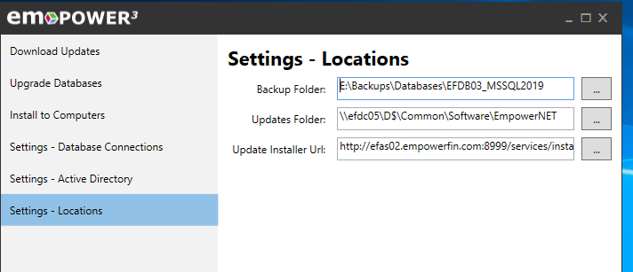
After verifying or changing the Backup Folder Location click the Save button at the bottom of the window.

Backup Databases
- EmpowerSupport displays your default database and version under the Upgrade Databases banner. You do not need to change what is shown as it is the latest version of your default database.
- You DO NOT want to Upgrade your database. Ignore this button.

- Instead, click the Backup button at the bottom of the window.
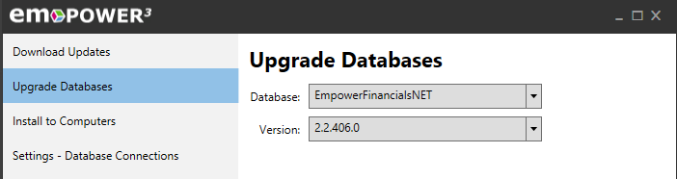
Empower Support displays a message letting you know the database is being backed up.
You can run this option at any time. Users do not have to be out of the EmpowerWin application.
- If you have more than one EmpowerWin database ( it is common to have a test database or separate databases for multiple companies) be sure to update each one by using the drop-down button in the Database column and then clicking the Backup button again.
- You can now close Empower Support. It is a good idea to then use File Explored and check that a new file with an extension of .BAK is in the database backup folder.

